Feature Distributions & Transformations

Skewness

Skewness measures asymmetry in the distribution.

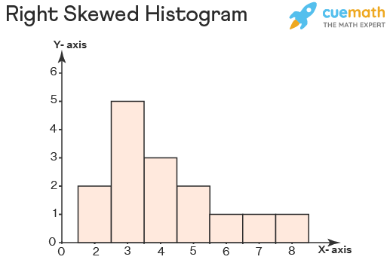

Positive Skew (Right Skew)
- Tail on the right
- Few extremely large values
- Mean > Median
Example: income, transaction amount
- 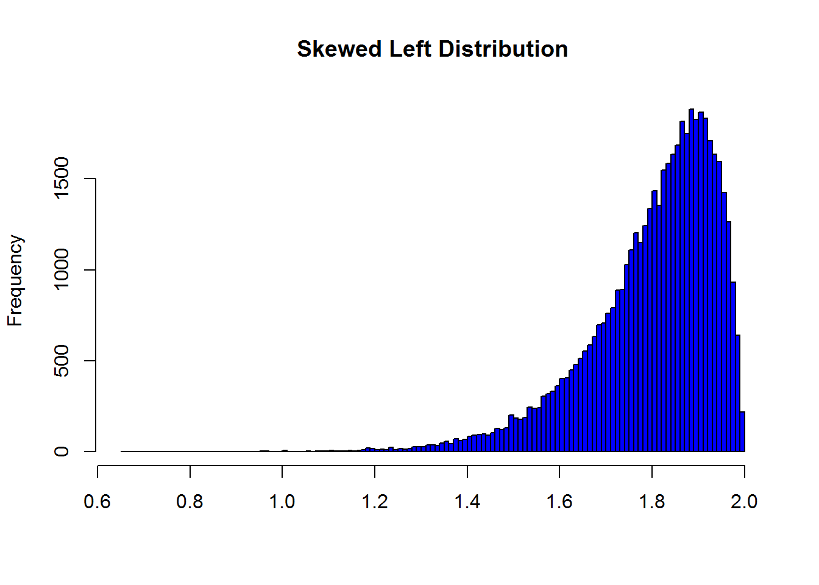

Negative Skew (Left Skew)
- Tail on the left
- Few extremely small values
- Mean < Median

- 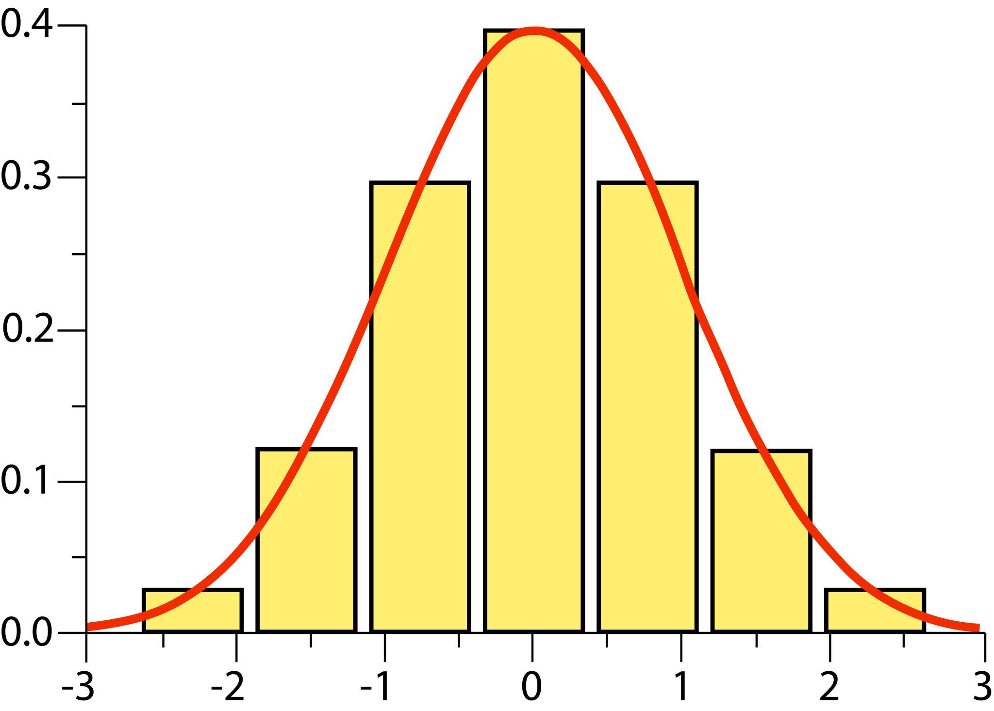

Zero Skew
- Symmetric
- Normal distribution

Interpretation Guide
- Skewness ≈ 0 → roughly symmetric
- Between -0.5 and 0.5 → fairly normal
- 1 or < -1 → highly skewed

Kurtosis
Kurtosis measures tail heaviness
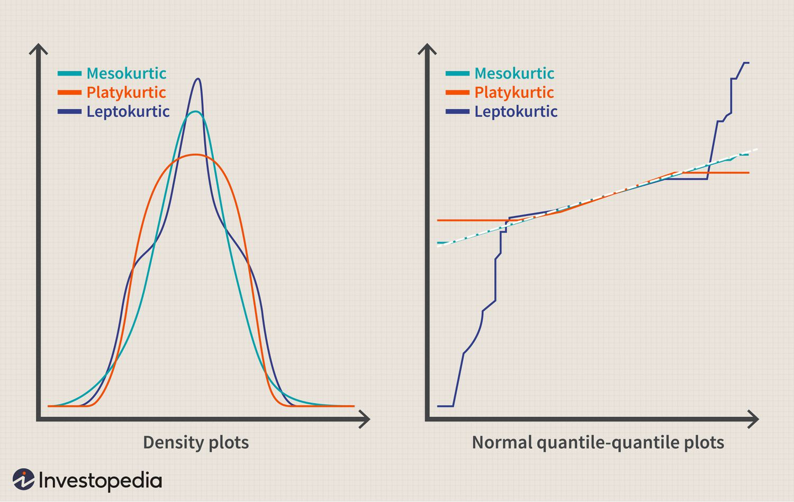

1. Leptokurtic (High Kurtosis)
- Heavy tails
- More extreme outliers
- Risky data

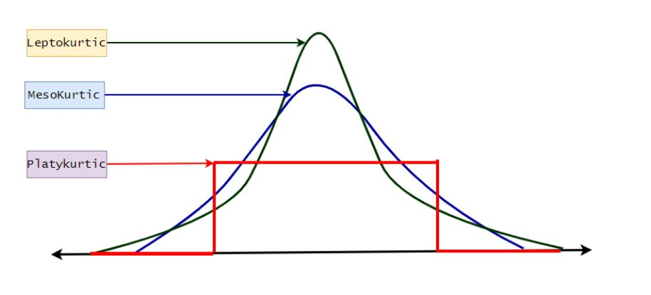

2. Platykurtic (Low Kurtosis)
- Light tails
- Fewer extreme values
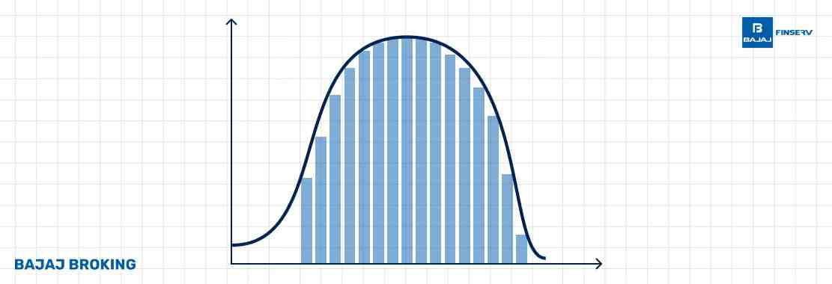

3. Mesokurtic
- Normal distribution level

If:
- Skewness is high → model may struggle (especially linear models)
- Kurtosis is high → outliers heavily influence mean & variance

Skewness → Direction of tail
Kurtosis → Weight of tail
If skewness tells you where imbalance is,
kurtosis tells you how dangerous the extremes are.

Log Transformation
Compresses large values more than small ones.
If data looks like:
1, 5, 10, 5000, 20000
After log:
0, 1.6, 2.3, 8.5, 9.9
Huge values shrink dramatically.

When to use
✔ Right-skewed data
✔ All values ≥ 0
✔ Large outliers
✔ Financial / transaction data
Example: Credit card Amount

When NOT to use
✖ Negative values
✖ Data already symmetric
✖ Tree-based models

Box-Cox Transformation

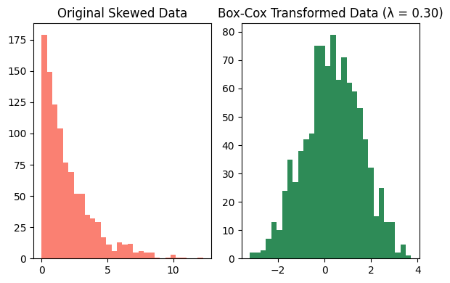
This is a smarter version of log.
Instead of forcing log, it finds the best power (λ) automatically.
Formula:
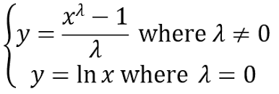
It chooses λ that makes data closest to normal.

When to use
✔ Data strictly > 0
✔ You want near-normal distribution
✔ Linear models

Limitation
🚫 Fails if:
- Zero values
- Negative values
Even one zero → error.

Yeo-Johnson Transformation
This is Box-Cox’s smarter version.
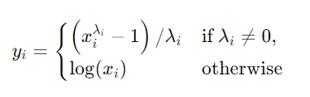
Works with:
✔ Zero
✔ Negative values
✔ Positive values
More flexible.

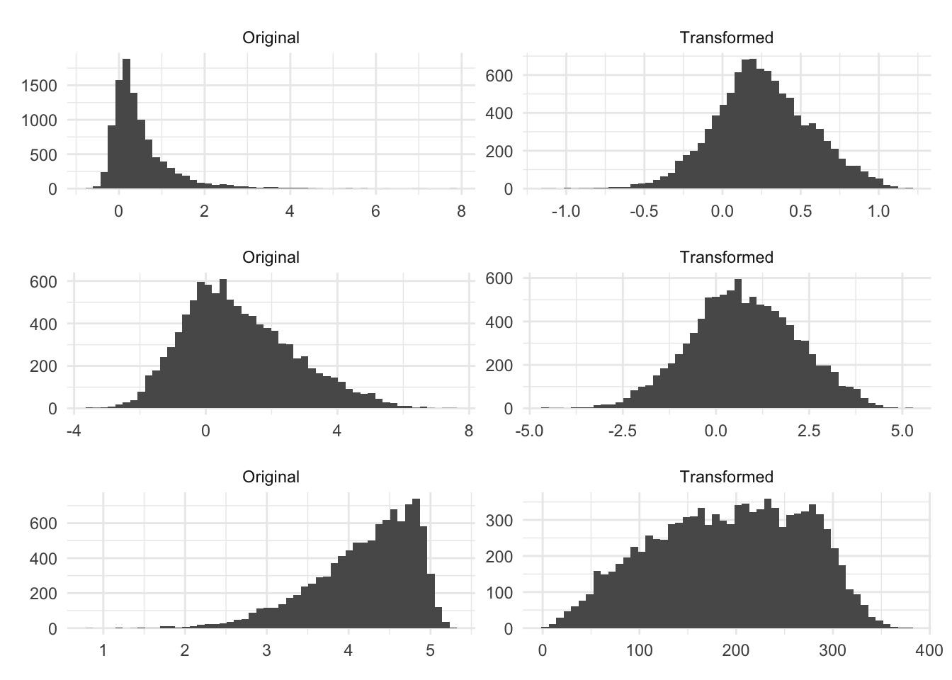

If skewness > 1:
- Try log first (if all positive)
- If zeros/negatives → Yeo-Johnson
- If strictly positive and want optimal → Box-Cox
Then compare model performance.

When Transformations Actually Help

When the Feature is Highly Skewed
If a feature has long tails, models that assume balanced distributions struggle.
Example:
Transaction amounts
Most values:
10, 20, 30, 40
Few extreme ones:
5000, 10000
That creates right skew.
Transformations like log or Box-Cox compress those extreme values, making the distribution more balanced.

When Using Linear Models
Linear models assume relationships that behave nicely with scaled, symmetric data.
Examples:
- Linear Regression
- Logistic Regression
If your features are extremely skewed, the model’s coefficients get dominated by extreme values.
Transformation reduces that problem.

When Using Distance-Based Algorithms
Distance algorithms are sensitive to magnitude differences.
Examples:
- KNN
- K-Means
- SVM (especially with RBF kernel)
If one feature has massive values due to skew, it dominates the distance calculation.
Transformation reduces that imbalance.

When Gradient Descent Optimization Struggles
Models trained with gradient descent converge faster when data distributions are smoother.
Examples:
- Neural Networks
- Logistic Regression
Skewed distributions can slow convergence.
Transformations make training more stable.

When Transformations DON’T Help Much
For tree-based models, transformations rarely matter.
Examples:
- Decision Trees
- Random Forest
- Gradient Boosting
- XGBoost
Why?
Because trees split data like this:
Amount < 200
Amount ≥ 200
Trees split on thresholds. They don’t care about shape.

